Creating Video Recording / Managing App

1. Create New Project: Single View, Core Data
2. Name: MyVideoApp
3. Add CoreData Entity and Attributes  
   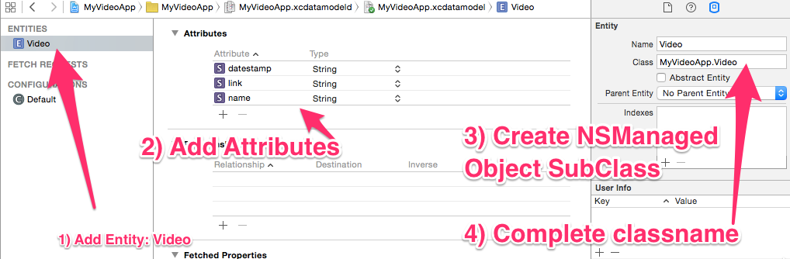
4. Go to StoryBoard and select ViewController
   1. Set Title:  **Video**
   2. Add objects to Viewcontroller  
      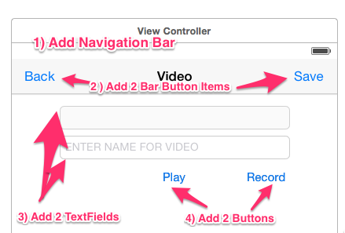
      1. Outlets/Actions/Delegates
      2. Outlets
         1. btnSave
         2. btnPlay
         3. btnRecord
         4. txtDate
         5. txtName
      3. Actions
         1. btnSave
         2. btnPlay
         3. btnRecord
         4. btnBack
      4. Delegate
         1. txtName
5. Add TableViewController to StoryBoard
6. Add New TableViewController Class & Name VideoTableViewController
7. Bind VideoTableViewController class to new TableViewController  
   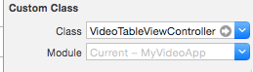
8. Select TableViewController > Editor > Embed In Navigation Controller
9. Select VideoTableViewController
   1. Drag 2 Bar Button Items (Left & Right)
      1. Left Title: < Back
      2. Right Identifier: Add
   2. Title: **My Video**
   3. Control Drag **Add** button to ViewController and Select “Present Modal”
   4. Select **Detail**
      1. Change Style to **Right Detail**
      2. Type  **Cell** in identifier
      3. Control Drag **Detail** to ViewController and Select “Present Modal”
      4. Segue Identifier: **video**
   5. Bind back button as action and name **btnBack**
10. Add NEW ViewController to StoryBoard
11. Add New ViewController Class & Name: **MainViewController**
12. Bind **MainViewController** to new ViewController

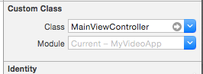

1. Change **MainViewController** to “Initial View Controller”
   1. Add Button to middle of view
   2. Create “Present Modal” Segue to Navigation Controller  
      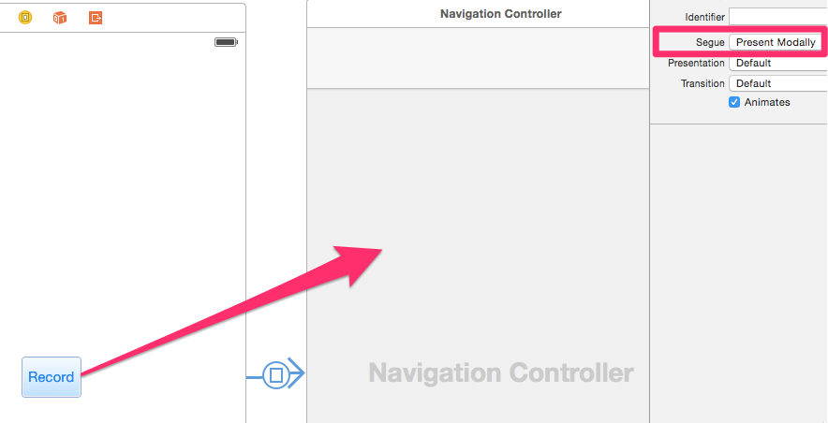
2. Add User Permissions to **info.plist** file
   1. Right-click > Open As Source File
   2. Add below lines above <key>UILaunchStoryboardName</key>  
      <key>NSCameraUsageDescription</key>

<string>You can take videos.</string>

<key>NSMicrophoneUsageDescription</key>

<string>Microphone Usage</string>

<key>NSPhotoLibraryUsageDescription</key>

<string>You can select videos.</string>

1. Add Code for [ViewController](https://raw.githubusercontent.com/ioscourse/iOSBootCamp-MyVideoApp/master/MyVideoApp/ViewController.swift)
2. Add Code for [VideoTableViewController](https://raw.githubusercontent.com/ioscourse/iOSBootCamp-MyVideoApp/master/MyVideoApp/VideoTableViewController.swift)
3. Test App
   1. Tap **Record** button
   2. Tap **+** button
   3. Enter a Name for Video
   4. Tap **Record** button
   5. Tap **Save button**
   6. Tap new video name row
   7. Tap **Play**
   8. Tap **< Back**
   9. Swipe Left on video name row and select **Delete**
4. **What else do you need to Add?**
   1. Add Image to **LaunchScreen**
   2. Add Nicer Layout on MainViewController
   3. Create icon for App. View [link](https://github.com/ioscourse/iOSBootCamp-MyVideoApp/blob/master/CreateIcons.pdf)